**Amazon Products Case Study**

**Analysis & Dashboard Report**

**Dataset Summary:** Product listings with fields such as product category levels, prices (discounted & actual), ratings, reviews, revenue, and score metrics.

**Analysis Task**

**Key Tasks and Insights**

**1. What is the average discount percentage by product category?**

Analysing the average discount per category helps understand:

* Which product types receive the most discounts.
* Potential markdown strategies and pricing inefficiencies.
* Which also show that Home Improvement category has the highest average discount percentage and Toy and Games have 0%.

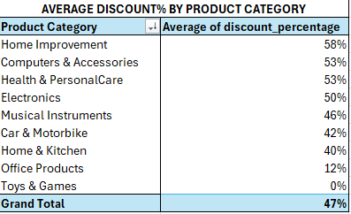

**2. How many products are listed under each category?**

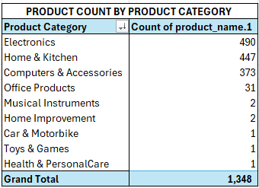

This data table summarizes the **number of products available by category**. The breakdown reveals a significant concentration of products in just a few categories:

* **Electronics** represent the largest portion with 490 products, accounting for about 36% of the total.
* **Home & Kitchen** follows closely at 447 products (approximately 33%).
* **Computers & Accessories** is third, with 373 products (about 28%).

Together, these three categories make up the vast majority of the inventory, totaling 1,310 products, or roughly **97% of all products listed**.

The remaining categories—**Office Products, Musical Instruments, Home Improvement, Car & Motorbike, Toys & Games, and Health & PersonalCare**—are sparsely represented, each with only 1 to 31 products.

**Key observations:**

* There is a **high concentration** of products in Electronics, Home & Kitchen, and Computers & Accessories.
* All other categories are **underrepresented**, indicating either a niche focus, early stage inventory expansion, or potential areas for growth if increased diversification is desired.
* The total product count is **1,348**.

This concentration may impact sales strategy, inventory management, and marketing focus, as the business appears to rely heavily on a small number of product categories for its offerings

**3. What is the total number of reviews per category?**

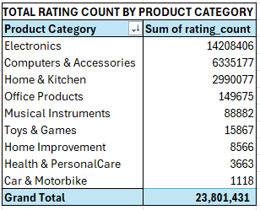

**Key Findings**

**1. Ratings are Highly Concentrated in a Few Categories**

* **Electronics** leads by a wide margin, with **14,208,406 ratings** (≈60% of total).
* **Computers & Accessories** follows with **6,335,177 ratings** (≈27%).
* **Home & Kitchen** ranks third with **2,990,077 ratings** (≈13%).

These three categories account for over **97% of all ratings** (23,533,660 out of 23,801,431).

**2. Other Categories Have Low Engagement**

* The remaining **six categories** collectively account for less than **2% of the ratings**:
  + **Office Products:** 149,675 (0.6%)
  + **Musical Instruments:** 88,882 (0.4%)
  + **Toys & Games:** 15,867 (0.07%)
  + **Home Improvement:** 8,566 (0.04%)
  + **Health & PersonalCare:** 3,663 (0.02%)
  + **Car & Motorbike:** 1,118 (<0.01%)

**3. Market Focus**

* **Electronics and Computing** (the two largest categories) together make up **over 87% of total ratings**, suggesting:
  + A likely business focus on tech and electronics,
  + Strong customer engagement and/or sales in these categories.

**4. Potential Opportunities**

* **Low-rated categories** (Office Products, Toys, Health, etc.) could indicate:
  + Niche or emerging markets within the inventory,
  + Areas for potential growth by expanding inventory or marketing,
  + Product assortment may need review for diversification purposes.

**5. Relative Engagement**

* Combining this ratings data with the product counts reveals:
  + **Electronics and Computers & Accessories** not only have the most products but also the highest engagement per product.
  + **Other categories** have both low product numbers and low engagement, amplifying the skew.

**Summary Table of Key Metrics**

|  |  |  |
| --- | --- | --- |
| Product Category | Rating Count | % of Total Ratings |
| Electronics | 14,208,406 | 59.7% |
| Computers & Accessories | 6,335,177 | 26.6% |
| Home & Kitchen | 2,990,077 | 12.6% |
| All Others (combined) | 267,771 | 1.1% |
| Total | 23,801,431 | 100% |

**Business Implications & Recommendations**

* **Double down** on Electronics and Computers: Continue to maintain and optimize these core categories.
* **Evaluate** minor categories: Reconsider allocation of resources or initiate targeted campaigns to boost engagement in underperforming categories.
* **Seek diversification** if desired: Consider expanding assortment or improving visibility for the long tail of your product offering.

**4. Which products have the highest average ratings?**

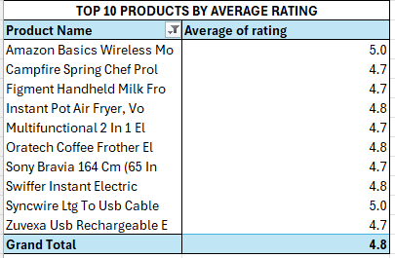

**Key Observations:**

* **Average rating across the Top 10:** **4.8** – This shows that only highly-rated products are featured.
* **Rating Distribution:**
  + **2 products** scored the maximum 5.0.
  + **6 products** scored **4.7**.
  + **2 products** scored **4.8**.
* **Product Types:**  
  The selection includes a mix of consumer electronics (wireless mouse/cable, TV), kitchen appliances (air fryer, chef pro, milk frother), and household products (Swiffer).

**Insights:**

* **High Consistency:** The difference between the lowest and highest rating in the top 10 is only 0.3, suggesting consistently positive customer feedback for these products.
* **Categories Represented:** The list is dominated by **electronics and kitchen/household gadgets**, indicating these types are likely to achieve higher customer satisfaction.
* **Actionable Points:**
  + Products with **5.0** ratings (Amazon Basics Wireless Mo, Syncwire Ltg To Usb Cable) are standouts and excellent for promotion or bundling.
  + The presence of multiple kitchen gadgets suggests this is a strong segment; consider expanding offerings here.
  + Maintaining top-rated items will help sustain positive brand perception.

|  |  |
| --- | --- |
|  |  |

**Conclusion**

* **Two products have the highest possible rating (5.0):**  
  **Amazon Basics Wireless Mo** and **Syncwire Ltg To Usb Cable**.
* **Overall, these top 10 products demonstrate excellent customer satisfaction**, especially among electronics and kitchen appliances.
* Consider focusing on or expanding these well-rated categories to further drive success.

**5. What is the average actual price vs the discounted price by category?**

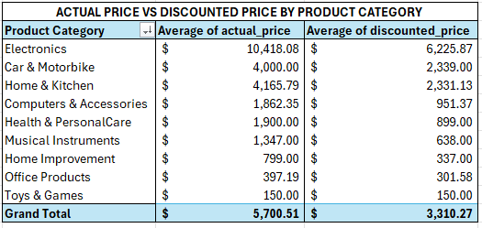

**Overall Trends:**

* **Significant Discounting:** Across all product categories (except for "Toys & Games"), there's a noticeable difference between the average actual price and the average discounted price, indicating that products are generally sold at a discount.
* **Average Discount:** The grand total shows an average actual price of $5,700.51 and an average discounted price of $3,310.27. This represents an average discount of approximately $2,390.24, or about 41.9% off the actual price.

**Category-Specific Observations:**

* **Highest Actual Price Categories:** "Electronics" ($10,418.08) and "Car & Motorbike" ($4,000.00) have the highest average actual prices.
* **Highest Discounted Price Categories:** Similarly, "Electronics" ($6,225.87) and "Car & Motorbike" ($2,339.00) also have the highest average discounted prices.
* **Largest Absolute Discount:** "Electronics" has the largest absolute discount ($10,418.08 - $6,225.87 = $4,192.21).
* **Deepest Percentage Discounts (Approximate):**
  + **Health & PersonalCare:** ($1900 - $899) / $1900 ≈ 52.7%
  + **Musical Instruments:** ($1347 - $638) / $1347 ≈ 52.7%
  + **Home Improvement:** ($799 - $337) / $799 ≈ 57.8% (This appears to have the highest percentage discount)
* **Lowest Actual Price Categories:** "Toys & Games" ($150.00) and "Office Products" ($397.19) have the lowest average actual prices.
* **No Discount:** "Toys & Games" shows no discount, with the average actual price and average discounted price both being $150.00. This could indicate that these items are rarely discounted or are entry-level products with slim margins.
* **Computers & Accessories:** Shows a substantial discount from $1,862.35 to $951.37, representing a discount of about 48.9%.

**Potential Interpretations/Further Questions:**

* **Discounting Strategy:** The data suggests a clear strategy of offering discounts across most product categories. The extent of the discount varies significantly by category.
* **Profit Margins:** Categories with higher actual prices (like Electronics) might be able to absorb larger absolute discounts while still maintaining healthy profit margins, assuming their cost of goods is proportionally lower.
* **Sales Volume:** This data doesn't show sales volume. A category with a small average discount might still contribute significantly to revenue if it has high sales volume. Conversely, categories with deep discounts might be used to drive traffic or clear inventory.
* **Customer Behavior:** Do customers primarily purchase items when they are discounted?
* **Market Competitiveness:** The level of discounting might also reflect the competitiveness within each product category.

In summary, the data clearly illustrates the pricing strategy across different product categories, highlighting the prevalence and varying degrees of discounting, with "Home Improvement" showing the highest percentage discount and "Electronics" having the largest absolute discount. "Toys & Games" stands out as the only category with no apparent discount.

**6. Which products have the highest number of reviews?**

The table shows the top 5 products with the highest number of reviews in order.

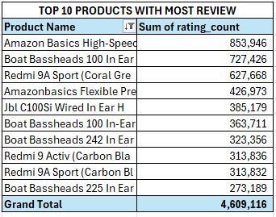

**Key Takeaways:**

* **Consumer Engagement**: The products on this list are highly engaging for consumers, prompting them to leave reviews. This could be due to their widespread use, value for money, or effective marketing encouraging reviews.
* **Brand Loyalty/Recognition**: Amazon Basics, Boat Bassheads, and Redmi have established strong brand recognition, leading to high sales and subsequent reviews.
* **Importance of Reviews**: For these products, the sheer volume of reviews likely plays a significant role in their continued sales and visibility, as reviews build trust and inform potential buyers.
* **Product Type Influence**: Entry-level or widely used accessories (like earphones/cables) and popular budget smartphones tend to garner a large number of reviews.

**7. How many products have a discount of 50% or more?**

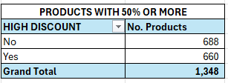

**Overall Summary:**

* The table categorizes products based on whether they have a "high discount," which is defined as 50% or more.
* The total number of products analyzed is 1,348.

**Key Observations**:

1. **Products without High Discount (Less than 50% discount)**: There are 688 products that do not have a 50% or more discount. This represents a larger portion of the products.
   * **Percentage**: (688/1348)∗100≈51.04%
2. **Products with High Discount (50% or more discount)**: There are 660 products that have a 50% or more discount.
   * Percentage: (660/1348)∗100≈48.96%

**Interpretation**:

* **Nearly Even Split**: The most striking observation is the near even split between products with a high discount (50% or more) and those without. Approximately 49% of the products have a discount of 50% or greater, while about 51% have a discount of less than 50%.
* **Aggressive Discounting Strategy**: This suggests that the entity managing these products employs a significant discounting strategy, with nearly half of its product catalog being offered at a very substantial discount.
* Potential Reasons for High Discounts:
  + **Inventory Clearance**: Selling off old or slow-moving stock.
  + **Promotional Activities**: Attracting new customers or boosting sales during specific periods (e.g., flash sales, holiday sales).
  + **Competitive Pricing**: Responding to competitor pricing or maintaining market share.
  + **Loss Leaders**: Selling some products at a loss (or very low margin) to drive traffic or encourage purchases of other, higher-margin items.
  + **Product Lifecycle**: Discounting products that are nearing their end-of-life cycle or are about to be replaced by newer models.

**8. What is the distribution of product ratings (e.g., how many products are rated 3.0, 4.0, etc.)?**

|  |  |
| --- | --- |
| **DISTRIBUTION OF PRODUCT RATING** | |
| **RATING** | **No. Products** |
| 5.0 | 2 |
| 4.8 | 3 |
| 4.7 | 6 |
| 4.6 | 16 |
| 4.5 | 68 |
| 4.4 | 114 |
| 4.3 | 209 |
| 4.2 | 207 |
| 4.1 | 225 |
| 4.0 | 159 |
| 3.9 | 114 |
| 3.8 | 84 |
| 3.7 | 41 |
| 3.6 | 34 |
| 3.5 | 26 |
| 3.4 | 10 |
| 3.3 | 15 |
| 3.2 | 2 |
| 3.1 | 4 |
| 3.0 | 3 |
| 2.9 | 1 |
| 2.8 | 2 |
| 2.6 | 1 |
| 2.3 | 1 |
| 2.0 | 1 |
| **Grand Total** | **1,348** |

**Overall Summary:**

* The data represents the distribution of product ratings across a total of 1,348 products.
* Ratings are provided on a scale, likely out of 5.0.

**Key Observations and Trends:**

1. **Dominance of Higher Ratings:**
   * The vast majority of products have ratings between 4.0 and 4.5.
   * The highest number of products are concentrated in the 4.1 to 4.4 range, with 225 products at 4.1, 207 at 4.2, 209 at 4.3, and 114 at 4.4.
   * This indicates a strong overall positive customer sentiment towards the products.
2. **Peak Rating at 4.1 and 4.3:**
   * The rating of 4.1 has the highest count with 225 products.
   * Following closely, 4.3 has 209 products, and 4.2 has 207 products.
3. **Few Perfect/Near Perfect Ratings:**
   * Only 2 products achieved a perfect 5.0 rating.
   * Very few products are at the extremely high end (4.8, 4.7, 4.6), suggesting that while products are generally well-received, perfect scores are rare.
4. **Steep Drop-off for Lower Ratings:**
   * There's a significant drop in the number of products as the rating decreases below 4.0.
   * Ratings below 3.0 are extremely rare, with only 1 product each at 2.9, 2.6, 2.3, and 2.0, and 2 products at 2.8 and 3.2, 3 products at 3.0 and 4 products at 3.1.
   * This indicates that very poorly rated products are an anomaly in this dataset.
5. **Average Rating (Estimated):** While not explicitly calculated, the distribution heavily skews towards the higher end (4.0-4.5), suggesting that the average product rating for this dataset would likely be around 4.1 to 4.3.

**Implications:**

* **Customer Satisfaction:** The data points to a generally high level of customer satisfaction with the products.
* **Product Quality:** Most products are perceived as good to very good in terms of quality or performance, as reflected by their ratings.
* **Trust and Reputation:** A strong distribution of high ratings can build trust with potential customers and enhance the brand's reputation.
* **Areas for Improvement:** While generally positive, the scarcity of perfect 5.0 ratings suggest there's always room for marginal improvements that could push more products into the highest rating tiers. The few low-rated products might be outliers or indicate specific issues that need attention.

**9.** **What is the total potential revenue (actual_price × rating_count) by category?**

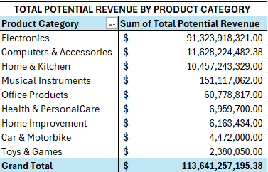

**Overall Summary:**

* The total potential revenue across all listed product categories is a staggering $113,641,257,195.38 (over 113 billion dollars). This indicates a very large-scale operation or market being analyzed.

**Key Observations and Trends by Product Category:**

1. **Dominance of Electronics:**
   * "Electronics" stands out as the absolute dominant category, with a potential revenue of $91,323,918,321.00.
   * This single category accounts for approximately 80.36% ($91,323,918,321.00 / $113,641,257,195.38 * 100) of the total potential revenue. This means Electronics is by far the biggest revenue driver.
2. **Second Tier Categories:**
   * "Computers & Accessories" ($11,628,224,482.38) and "Home & Kitchen" ($10,457,243,329.00) form a second tier. While substantial on their own, they are dwarfed by "Electronics."
   * Combined, these three categories ("Electronics", "Computers & Accessories", "Home & Kitchen") account for the vast majority of the total potential revenue.
3. **Significant Drop-off to Lower Tiers:**
   * There's a massive drop in potential revenue after the top three categories.
   * "Musical Instruments" ($151,117,062.00) and "Office Products" ($60,778,817.00) represent a third tier, with revenues in the hundreds of millions and tens of millions, respectively.
   * The remaining categories ("Health & PersonalCare", "Home Improvement", "Car & Motorbike", "Toys & Games") have potential revenues in the single-digit millions, which are comparatively very small.
4. **Long Tail of Categories:**
   * The data exhibits a long-tail distribution, where a few categories contribute the bulk of the revenue, while many others contribute much smaller amounts.
   * For instance, "Toys & Games" has the lowest potential revenue at $2,380,050.00, which is less than 0.002% of the total.

**Implications:**

* **Strategic Focus:** The business (or market) should clearly prioritize "Electronics" due to its overwhelming potential revenue contribution.
* **Resource Allocation:** Significant resources (marketing, inventory, R&D, sales efforts) should likely be directed towards "Electronics," followed by "Computers & Accessories" and "Home & Kitchen."
* **Growth Opportunities:** While the smaller categories contribute less in absolute terms, their relative growth rates or strategic importance (e.g., niche markets, complementary products) might still be relevant for overall business strategy, even if their current potential revenue is low.
* **Market Concentration:** The high concentration of revenue in "Electronics" could indicate a strong market position or a highly valued product set within that category. It also suggests a potential vulnerability if that market segment faces significant disruption or competition.

**10. What is the number of unique products per price range bucket (e.g., <₹200, ₹200–₹500, >₹500)?**

This is showing the number unique products per price range.

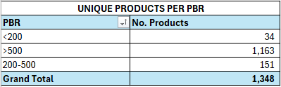

**11. How does the rating relate to the level of discount?**

|  |  |
| --- | --- |
| **DISCOUNT % VS AVERAGE RATING** | |
| **Discount %** | **Average of rating** |
| 0% | 4 |
| 2% | 5 |
| 3% | 4 |
| 4% | 4 |
| 5% | 4 |
| 6% | 4 |
| 7% | 4 |
| 8% | 4 |
| 9% | 4 |
| 10% | 4 |
| 11% | 4 |
| 12% | 4 |
| 13% | 4 |
| 14% | 4 |
| 15% | 4 |
| 16% | 4 |
| 17% | 4 |
| 18% | 4 |
| 19% | 4 |
| 20% | 4 |
| 21% | 4 |
| 22% | 4 |
| 23% | 4 |
| 24% | 4 |
| 25% | 4 |
| 26% | 4 |
| 27% | 4 |
| 28% | 4 |
| 29% | 4 |
| 30% | 4 |
| 31% | 4 |
| 32% | 4 |
| 33% | 4 |
| 34% | 4 |
| 35% | 4 |
| 36% | 4 |
| 37% | 4 |
| 38% | 4 |
| 39% | 4 |
| 40% | 4 |
| 41% | 4 |
| 42% | 4 |
| 43% | 4 |
| 44% | 4 |
| 45% | 4 |
| 46% | 4 |
| 47% | 4 |
| 48% | 4 |
| 49% | 4 |
| 50% | 4 |
| 51% | 4 |
| 52% | 4 |
| 53% | 4 |
| 54% | 4 |
| 55% | 4 |
| 56% | 4 |
| 57% | 4 |
| 58% | 4 |
| 59% | 4 |
| 60% | 4 |
| 61% | 4 |
| 62% | 4 |
| 63% | 4 |
| 64% | 4 |
| 65% | 4 |
| 66% | 4 |
| 67% | 4 |
| 68% | 4 |
| 69% | 4 |
| 70% | 4 |
| 71% | 4 |
| 72% | 4 |
| 73% | 4 |
| 74% | 4 |
| 75% | 4 |
| 76% | 4 |
| 77% | 4 |
| 78% | 4 |
| 79% | 4 |
| 80% | 4 |
| 81% | 4 |
| 82% | 4 |
| 83% | 4 |
| 84% | 4 |
| 85% | 4 |
| 86% | 4 |
| 87% | 4 |
| 88% | 4 |
| 89% | 4 |
| 90% | 4 |
| 91% | 4 |
| 94% | 4 |
| **Grand Total** | **4** |

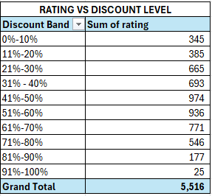

* **Discount Bands:** This table categorizes products into 10% discount bands and shows the "Sum of rating" within each band.
* **High Discount (50% and above):**
  + **51%-60%:** Sum of rating = 936
  + **61%-70%:** Sum of rating = 771
  + **71%-80%:** Sum of rating = 546
  + **81%-90%:** Sum of rating = 177
  + **91%-100%:** Sum of rating = 25
* **Total Sum of Rating for High Discount:** 936+771+546+177+25=2,455
* **Total Sum of Rating for All Discounts:** 5,516
* **Percentage of Total Sum of Ratings in High Discount Bands:** (2,455/5,516)∗100≈44.51%

**"DISCOUNT % VS AVERAGE RATING" (Average rating by specific Discount %)**

* **Individual Discount %:** This table lists specific discount percentages and the "Average of rating" for products at that exact discount level.
* **High Discount (50% and above):** Looking at the "Average of rating" column from 50% down to 94%, the value is consistently **4**.

**Combined Analysis and Correlation (with high discount >= 50%):**

1. **Distribution of Sum of Ratings for High Discounts:**
   * When considering discounts of 50% and above, we see that the sum of ratings is highest in the 51%-60% band (936), then gradually decreases as the discount level gets higher (e.g., 25 for 91%-100%).
   * Roughly 44.5% of the *total sum of ratings* across all discount levels comes from products that have a "high discount" (50% or more). This indicates a significant portion of highly-rated products (or products with many ratings) are offered at substantial discounts.
2. **Average Rating Stability at High Discount Levels:**
   * Crucially, when we look at the specific average rating for products at individual discount percentages of 50% and above (from the second image), the average rating remains a **consistent 4**. This applies even to the very high discount percentages like 91% or 94%.

**Correlation between Rating and Level of Discount (revisiting previous analysis with the "high discount" definition):**

* **Overall Trend from "Sum of Rating":** The first table (Sum of rating) suggests a peak in rating activity (sum of ratings) in the mid-range discount bands (41%-50% and 51%-60%). As discounts become extremely high (e.g., 80%+), the sum of ratings significantly drops.
  + This implies that while good products might be discounted, extremely high discounts might be applied to fewer products, or products that don't generate as many reviews/ratings.
* **Overall Trend from "Average Rating":** The second table (Average of rating) provides a clearer picture of the *quality perception* by showing that the **average rating stays at 4 for nearly all discount percentages, including all "high discount" percentages (50% and above).** The previous chart showed this visually, with only minor dips at the very highest extreme percentages (around 85-89%) before recovering slightly.

**Conclusion on Correlation with "High Discount" starting from 50%:**

Based on the average rating, there is **no direct negative correlation** between applying a high discount (50% or more) and the *average rating* of the products. Products that receive high discounts (50% and above) still maintain a high average rating of **4**.

The only potential "correlation" is seen in the "Sum of rating" which suggests fewer products *exist* or are *rated* at the very highest discount tiers (80%+). However, the products that *do* exist and are rated in those highly discounted tiers still generally maintain a good average rating of 4.

Therefore, the data suggests that customers perceive the quality of products (as reflected by their average rating) to be consistently good, regardless of whether they are purchased at full price or with a high discount. High discounts do not seem to be a signal of lower quality products in terms of customer satisfaction.

**12. Products that have fewer than 1,000 reviews**

There are **307 Products** that have fewer than 1,000 reviews.

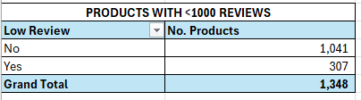

**13. Which categories have products with the highest discounts?**

Computer & Accessories have the product with the highest discounts follows Electronics Categories.

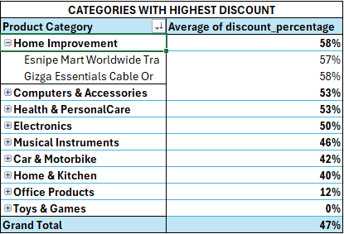

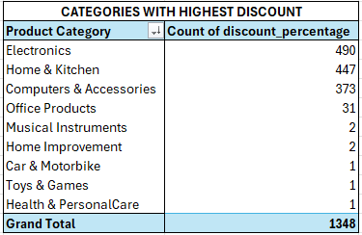

By comparing these two tables, we can gain a deeper understanding of the discounting strategies:

1. **High Volume of Discounted Products vs. Average Discount Depth:**
   * **Electronics, Home & Kitchen, and Computers & Accessories** have the *highest number of discounted products* (490, 447, and 373 respectively). This indicates that a large portion of their inventory or offerings frequently undergo discounting.
   * Simultaneously, **Electronics (50%) and Computers & Accessories (53%)** also have very *high average discount percentages*. This means not only are many products in these categories discounted, but the discounts themselves are deep. This aligns with them being high-potential revenue categories (as seen in image_18b516.png) and suggests an aggressive pricing strategy to drive volume.
   * **Home & Kitchen** has a high count of discounted products (447) but a relatively lower average discount of 40% compared to Electronics and Computers & Accessories. This suggests a strategy of frequent, but perhaps not always the deepest, discounts.
2. **Deep Discounts on Few Products:**
   * **Home Improvement (58%)** and **Health & PersonalCare (53%)** have the *highest average discount percentages*, indicating very deep discounts when they occur. However, the first table shows they only have **2 and 1 discounted products**, respectively. This implies that while the *average* discount for these categories is very high, it applies to a very limited number of items within those categories. This could be for specific clearance items, highly targeted promotions, or perhaps just a few very high-value items being deeply discounted.
3. **Low Volume, Moderate Discounts:**
   * **Musical Instruments (46%)** and **Car & Motorbike (42%)** have moderate average discounts but a very low count of discounted products (2 and 1 respectively). Similar to Home Improvement and Health & PersonalCare, discounting seems to be applied to specific, perhaps few, items in these categories.
4. **Low Volume, Low Discounts:**
   * **Office Products** has a very low average discount (12%) and also a relatively low count of discounted products (31). This reinforces the idea that Office Products are generally not heavily discounted, and fewer of them are discounted in the first place.
   * **Toys & Games** has a 0% average discount and only 1 product recorded as having a discount percentage (which would imply it's 0%). This consistently shows that this category is generally not subjected to price reductions.

**Overall Strategic Insights:**

* **Volume-Driven Discounts:** For categories like Electronics, Home & Kitchen, and Computers & Accessories, discounting appears to be a core strategy for moving large volumes of products.
* **Targeted/Selective Deep Discounts:** For categories like Home Improvement and Health & PersonalCare, extremely deep discounts are applied, but only to a very small number of products. This might be for specific inventory clearance, flash sales, or high-ticket items where a substantial discount can attract buyers without widespread impact on the entire category.
* **Non-Discounted Categories:** Toys & Games, and to a lesser extent Office Products, maintain higher full-price integrity, suggesting different market dynamics or profitability models for these categories.

This combined analysis paints a more complete picture, showing not just *how much* products are discounted on average, but also *how many* products within each category are actually being subjected to discounts.

**14. Identify the top 5 products in terms of rating and number of reviews combined.**

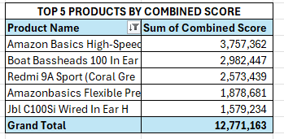

**Overall Summary:**

* The table presents the top 5 products ranked by a "Combined Score," which is likely a metric that consolidates various performance indicators (e.g., sales, reviews, ratings, engagement).
* The total combined score for these top 5 products is 12,771,163.

**Key Observations by Product:**

1. **Amazon Basics High-Speed:** This product holds the top position by a significant margin with a Combined Score of 3,757,362. This suggests it's an exceptionally high-performing product across the metrics used to calculate the combined score.
2. **Boat Bassheads 100 In Ear:** Ranks second with a Combined Score of 2,982,447. This product is clearly a strong performer, but still noticeably behind the top "Amazon Basics" item.
3. **Redmi 9A Sport (Coral Gre):** Secures the third spot with a Combined Score of 2,573,439. This confirms its strong performance, likely driven by factors beyond just review count.
4. **Amazonbasics Flexible Pre:** Another "Amazon Basics" product, coming in fourth with a Combined Score of 1,878,681. Its presence here reinforces the overall strong performance of "Amazon Basics" brand products.
5. **Jbl C100Si Wired In Ear H:** Completes the top 5 with a Combined Score of 1,579,234. This indicates its strong standing among audio accessories.

**Connections to Previous Analyses (especially "TOP 10 PRODUCTS WITH MOST REVIEW" ):**

* **Identical Top 5 Products:** It's highly notable that the "TOP 5 PRODUCTS BY COMBINED SCORE" list is *identical* to the top 5 products from the "TOP 10 PRODUCTS WITH MOST REVIEW" table , and in the *exact same order*.
  + **Amazon Basics High-Speed:** #1 in both lists.
  + **Boat Bassheads 100 In Ear:** #2 in both lists.
  + **Redmi 9A Sport (Coral Gre):** #3 in both lists.
  + **Amazonbasics Flexible Pre:** #4 in both lists.
  + **Jbl C100Si Wired In Ear H:** #5 in both lists.

**Interpretation and Implications:**

* **Strong Correlation:** The identical ranking strongly suggests that "Sum of rating count" (number of reviews) is either a primary component, or very highly correlated with, the "Combined Score." It's possible the combined score heavily weights or even primarily consists of review count, or that products with high review counts naturally perform well across other metrics.
* **Product Success:** The products in this top 5 are not only highly reviewed but also appear to be top performers across a broader set of metrics captured by the "Combined Score." This indicates their overall success and popularity.
* **Brand Strength:** "Amazon Basics," "Boat Bassheads," and "Redmi" (Xiaomi) are consistently identified as brands with top-performing products, solidifying their market presence.
* **Validation of Review Count as a Proxy:** If the combined score is truly a comprehensive measure, then the review count serves as an excellent proxy for identifying top-performing products in this dataset. This can be valuable for quick analysis or for understanding consumer engagement as a driver of overall success.

**Dashboard**

**Key Tasks and Insights**

**KPI Cards**

* Total Revenue is **$114BN**
* Average Discount % is **47%**
* Average Rating is **4.8%**
* Number of Products is **1348**

**Slicers (Filters)**

* Product Category (**Category**)
* Discount <= 50%
* Price Buckets

These allow users to filter the data dynamically and view performance

**DASHBOARD VIEW**

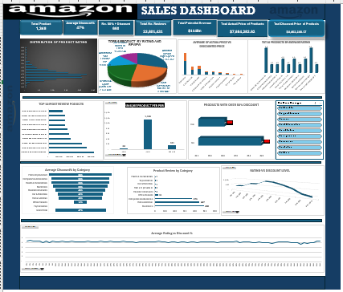

**TOP 5 PRODUCTS BY REVENUE**

These are the top 5 products in the chart, It displays the distribution of reviews for the top 5 products. Each slice represents a product, and the size of the slice corresponds to the number of reviews it has received.

Here's an analysis of the chart:

**Overall:**

* The chart clearly illustrates the top 5 products based on the number of ratings and reviews.
* The numbers accompanying each product name likely represent the total count of reviews or a combined metric of rating and review volume.

**Specific Product Analysis:**

1. **Amazon Basics High-Speed:** This product has the largest share of the pie, with **3,757,362** reviews. This indicates it is significantly more reviewed than the other products listed.
2. **Boat Bassheads 100 In Ear:** This product comes in second, with **2,982,447** reviews. It represents a substantial portion of the total reviews, though less than the Amazon Basics High-Speed.
3. **Redmi 9A Sport (Coral Gre):** Ranking third, this product has **2,573,439** reviews.
4. **Amazonbasics Flexible Pre:** This product is fourth with **1,878,681** reviews.
5. **Jbl C100 Si Wired In Ear H:** This product has the smallest share among the top 5, with **1,579,234** reviews.

**Key Takeaways:**

* **Dominance of Amazon Basics High-Speed:** This product clearly leads the pack in terms of review volume, suggesting high popularity or widespread adoption.
* **Strong Performance of Boat Bassheads:** This product is a strong contender, close behind the leader.
* **Significant Gap between Top 2 and Others:** There's a noticeable drop-off in review numbers after the top two products.
* **Variety of Products:** The top products span different categories (e.g., "High-Speed" (likely cable/tech accessory), "In Ear" headphones, "Redmi 9A Sport" (likely a phone)).

**Limitations/Assumptions:**

* **"Rating and Review":** The exact methodology for combining "rating" and "review" into a single metric isn't specified. It's assumed the numbers represent the total count of reviews.
* **Context Missing:** Without knowing the product categories or the platform from which this data was gathered (e.g., Amazon, Flipkart), a deeper analysis of market share or competitive landscape isn't possible.
* **"TOP 5":** The chart only shows the top 5. There might be a long tail of other products with fewer reviews.

In summary, the pie chart effectively visualizes the relative popularity of these five products based on their review volume, with Amazon Basics High-Speed standing out as the most reviewed.

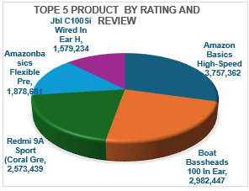

**TOP 5 CATEGORIES BY REVENUE**

The revenue distribution clearly highlights **Electronics** as the dominant category, generating over ₹56.6 billion — far outpacing all others. **Home & Kitchen** and **Computers & Accessories** follow distantly, while **Musical Instruments** and **Office Products** contribute minimal revenue in comparison.

*Key Observations:*

* **Electronics** alone drives the majority of total revenue.
* There’s a steep drop-off after the top category, indicating a highly skewed sales concentration.

*Recommendation:*

* Leverage the performance of Electronics with upselling and cross-selling strategies (e.g., pair with accessories).
* Explore ways to boost revenue in lower-performing categories through targeted promotions or product diversification.

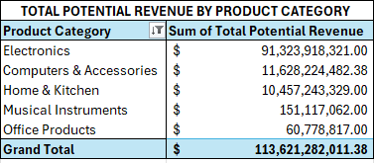

**REVENUE DISTRIBUTION BY PRICE BUCKET**  
The chart illustrates revenue distribution across three price segments: under **$** 200, **$**200 – **$**500, and above **$** 500. This breakdown helps identify which price range contributes most to overall revenue, informing pricing strategy and target audience focus. Further analysis could explore trends or shifts in consumer preference among these categories.

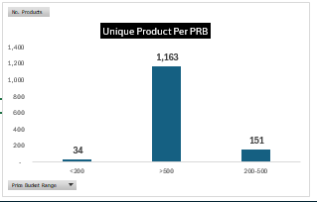

**DISCOUNT% VS AVERAGE RATINGS**

**Analysis of the Chart:**

* **X-axis (Horizontal):** Represents "discount_percentage", ranging from 0% up to around 90%. The labels are shown at various intervals (e.g., 0%, 5%, 9%, 13%, etc.).
* **Y-axis (Vertical):** Represents "Average of rating", ranging from 1 to 5.

**Key Observations and Trend:**

1. **Remarkable Consistency:** For the vast majority of discount percentages, the "Average of rating" hovers very consistently around **4**. The line stays remarkably flat across a wide range of discounts.
2. **Slight Fluctuations at Extremes:**
   * There are minor fluctuations. At very low discount percentages (0% to around 5%), the average rating is slightly above 4, possibly reaching around 4.2-4.3.
   * Towards the very high end of discounts (around 85% to 89%), there's a dip where the average rating drops below 4, possibly to around 3.5-3.7. However, it then appears to rebound slightly as the discount approaches 90%.
3. **Overall Stability:** Despite the minor dips and peaks, the dominant characteristic of this chart is the overall stability of the average rating. For most discount levels, a product's average rating remains consistently high (around 4).

**Correlation:**

* **Weak to No Direct Correlation:** This chart strongly supports the conclusion that there is **very little to no direct correlation** between the discount percentage and the average product rating.
* **Average Rating is Robust:** The average rating of products seems to be quite robust and is not significantly impacted by how much a product is discounted. This implies that customers generally rate products based on their intrinsic quality or performance, rather than the price they paid (or the discount they received).

**Comparison with "RATING VS DISCOUNT LEVEL”:**

This showed "Sum of rating" per discount band and indicated a curvilinear relationship (peaking in mid-range discounts and declining at very high discounts). This chart, however, shows "Average of rating" per specific discount percentage.

* The previous table's "Sum of rating" could have been influenced by the *number of products* in each band. If a band had many products, even with an average rating of 4, the sum would be high. If a band had very few products, the sum would be low.
* This current chart explicitly shows the *average rating* for each discount percentage. The fact that the average largely remains at 4, even where the "Sum of rating" might have been low in the previous table, suggests that the few products at those extreme discount levels *still maintained an average rating of 4*. The dip at 85-89% discount is the most significant deviation from this consistent average 4 rating, aligning with the idea that extremely high discounts might be applied to products that are slightly less well-received.

**Conclusion:**

The "Average Rating vs Discount %" chart visually confirms that, for the most part, the average rating of products remains stable at approximately 4, regardless of the discount applied. This suggests that product quality or customer satisfaction, as reflected by ratings, is largely independent of the discount level. The slight dip at very high discount percentages could indicate that products requiring extreme markdowns might be marginally less appealing, but overall, customer satisfaction remains high.